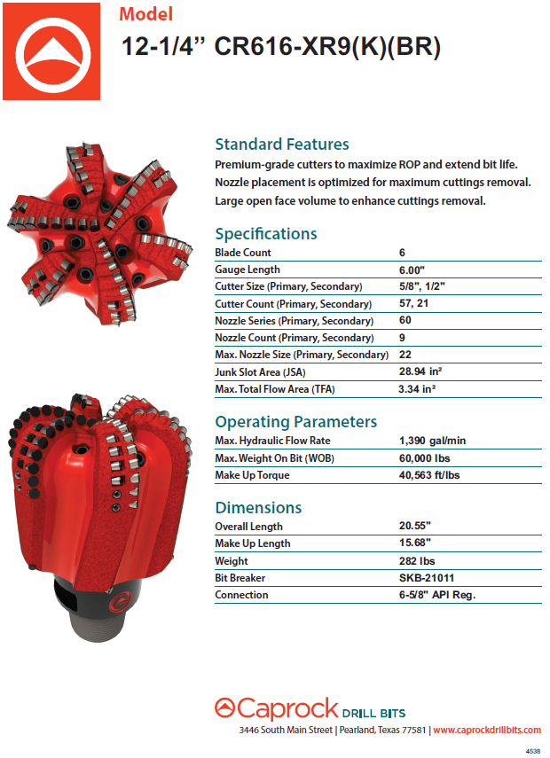

Highlights of the Ø12.25” 616-XR9(K)(BR) design:
- 42.9% PDC exposure at apex after hard metal allows for increased depth of cut.
- Blade relief in cone of bit allows for increased ROP.
- Top-Load back-up cutters increase PDC shear loads (more support behind the primary cutting structure).
- Helical protrusions behind primary PDC's add additional steel support to further increase PDC shear loads.
- Drafted blades with a large radius at the base drastically increase rigidity.
- Secondary blade webbing increases the rigidity of the secondary blades.
- The back-up cutters on this bit will not engage until the primary cutters show significant signs of failure.
- Nozzles are placed directly in front of planar PDC’s to minimize washout between cutters.
- This design distributes more work to the Primary blades (1,3,5) than the secondary blades (2,4,6) and it maintains the same work distribution percentages (Pri. vs Sec. Blade) at any depth of cut. This type of design is employed to increase ROP.

Primary Cutting Structure:
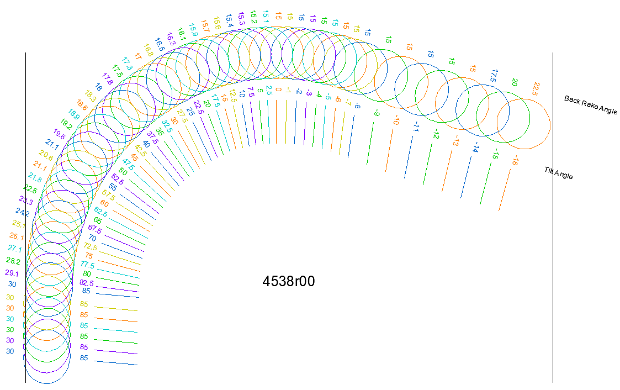

Blade 1 | Blade 2 | Blade 3 | Blade 4 | Blade 5 | Blade 6

Cutlet Plot:

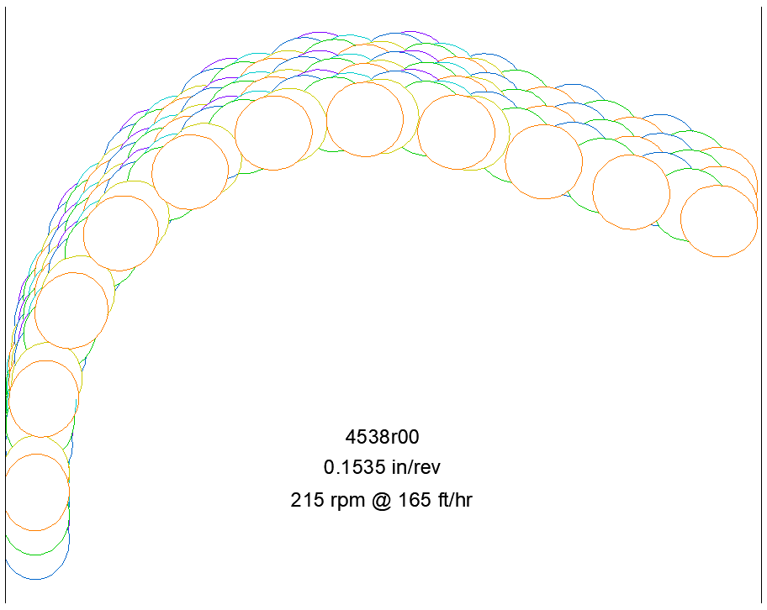

Distribution of forces by cutlet position (0.1535 in/rev; 215 rpm @ 165 ft/hr):

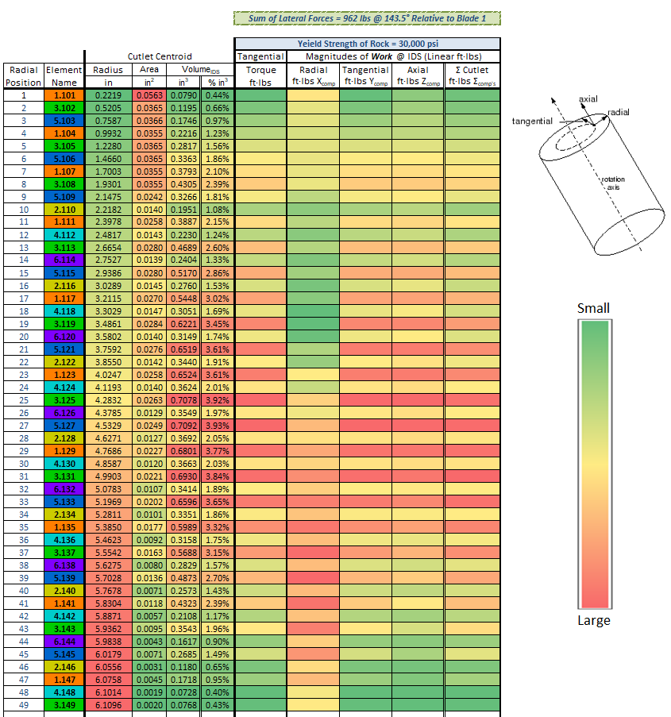

Radial Position: Position #1 is at the center of the bit. The position #’s increase with the radius.
Element Name:
- The # before the decimal is the blade # (the colors correspond to the drawings above).
- If the first # after the decimal is a 1, it’s a primary element position. If it is a 2, it’s a back-up position.
- The last two digits are the radial position.

